# grep Assignment

**Mandatory:**

1. Use any .c file. Using grep command extract and display
   1. all lines beginning with #include with line numbers

Ans) grep -n “^#include” filename is used to extract and display all lines beginning with that word

* 1. display all lines which do not begin with #include

Ans) ) grep -v “^#include” filename is used to display all lines donot begin with that particular word

* 1. display the line number of main()

Ans) grep -n “^int main(“ filename is used to display the line number with that word

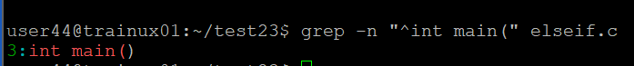

* 1. extract all lines containing characters of opening and closing parathesis {(,))

Ans) grep -n “[{}()]” filename.c is used to extract all lines containing characters of opening and closing parathesis {(,))

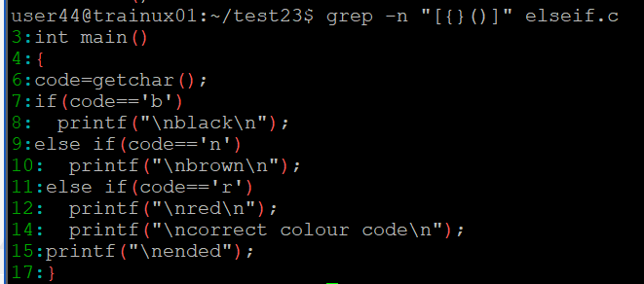

1. Perform the above operations on a set of *.c files

Ans) a) grep -n “^#include” *.c

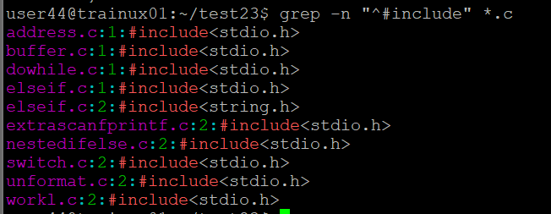

b) grep -n “^int main(“ *.c

